Date of Submission: 03/10/2023 Andre Watts

EXCEL/TABLEAU ASSIGNMENT

Contents

Policies and Procedures 2

Excel Data/GDP Tasks 3

Third Task Tableau 16

Reflection 20

# Policies and Procedures

The most important procedure when handling data protection. Data protection is the protection of sensitive information which can be lost, damaged or corrupted. Large amounts of data are stored and used so it has become more important than ever that the data is stored safely and is accessible quickly the people who need it. A small amount of data that is lost or damaged can cause huge loss of businesses who depend on that the data.

The most important data protection strategies are:

* Data security – protecting data from malicious or accidental damage.
* Data availability – Quickly restoring data in the event of damage or loss.
* Access control – ensuring that data is accessible to those who need it, and not to anyone else.

It is important for data analysts are aware as there are several regulations and compliance obligations data analysts must adhere to. Organizations or specific business units may be subject to a variety of regulations or industry-specific compliance standards. Some examples are:

* **European Union (EU): the GDPR**
* **The Federal Trade Commission Act** requires organizations to respect consumer privacy and adhere to privacy policies.
* **The Health Insurance Portability and Accountability Act (HIPAA)** regulates the storage, confidentiality, and use of health information.
* **The Gramm Leach Bliley Act (GLBA)** regulates the collection and storage of personal data by financial institutions.
* **The California Consumer Privacy Act (CCPA)** protects the right of California residents to access their personal information, ask for deletion, and request that their personal data will not be collected or resold.

Policies and procedures offer clarity and consistency on how to handle sensitive data and communicate why the need to follow these regulations. If you fail to comply with these regulations, the business can be fined up to 20 million euros or up to 4% of their total global turnover.

# Excel Data/GDP Tasks

1.

* Go to Review Tab
* Select Protect Workbook
* It will ask you to enter a password, but this is optional.

* CTRL+SHIFT+DOWN ARROW to highlight all C column values.
* Select Accounting Number Format in the number section.
* Select English (United Kingdom).

* CTRL A to highlight all the data.
* CTRL T to turn all the data into a table and tick ‘My table has headers’.

* Select the filter button in the D column next to Year of Information.
* Unselect all the years and just tick 2019 and click OK.

* Highlight top 20 ranking countries.
* Go to insert and insert a bar chart.

6.

* Add chart title.
* Add axis titles.
* Change the display units to Thousands.

7. 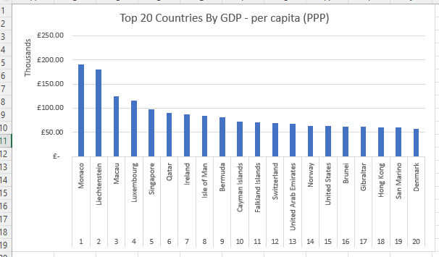

* CTRL C graph.
* Create new worksheet.
* CTRL V into new worksheet.

* Sort countries Rank from smallest to biggest.

9.

* Created a PivotTable and added Rank and Country to the column section and GDP to the value section.
* Select PivotChart and picked the bar chart option.
* Edited the graph by adding a chart title and axis titles.

10.

* Highlighted the area under the table.
* Selected the fill colour in the font section.
* Picked the blue colour fill.

1.

* Create three shapes.
* Go to view tab and Record Copy macro.
* Right click rectangle with copy and assign copy macro.

2.

* Use Copy button to copy worksheet on new word document.
* Title pages GDP (Gross Domestic Product).

3.

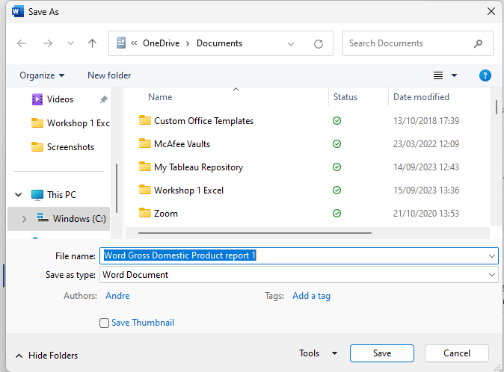

4.

* Go to the view tab.
* Select Page Layout to add header and footer.

* Add my name and the GLA DATA 1 to the header.

* Add the date, Assignment 1 and Data Visualisation to the footer.

* Change the view back to normal.

# Third Task Tableau

1.

* Import Wealth of Nations Data
* Set relationship by joining the choosing the country data to join the two data sets.

* Check data to see if there are any null values and if values are in the correct format.

4.

* Used a bar graph to represent countries by GDP per capita.
* Put countries in the filter section and filtered the top 20 countries.

* Used a bar graph to show the smartphone users of each country.
* Put countries in the filter section and filter the top 20 countries.

* Apply bar graph to show the average life expectancy of each country.
* Apply countries to the filter section and filter the top 20 ranking countries in life expectancy.

* Used a calculated field which consisted of adding the three different ranks for each category and dividing by three to get the average rank of each graph.
* Used the bar graph to visualise the average rank of each country.
* Put country in the filter to filter the top 20 average ranking countries.

6.

* Created a Dashboard and dragged my visualisations into the dashboard to show the top 20 ranking countries in each category.
* Added a dashboard title to make the dashboard focus clear.

# Reflection

I first used Excel to create data visualisations of the top 20 ranking countries by GDP per capita. This consisted of bar charts to represent the data. I then used Tableau to create data visualisations focusing on the top 20 ranking countries in each category.

Some issues I had was the use of Macro as it was not something I had done before so I had to do additional research in order to get a grasp on the concept. I had a few errors while working with Macro, but I believe I have a basic understanding on how it works. Another issue I had was the graphs were often very messy and cramped due to a lot of data being present. Therefore, it took a lot of editing to get into an acceptable state.

The considerations I had was to make the visualisations simple so a non-technical audience will be able to easily understand the data and make sensible decisions based on the data. Furthermore, I limited the use of colours, so it is accessible to colour-blind people as well. Too much colour would alienate colour-blind people as they wouldn’t be able to fully interpret the data.

Next time, the thing I would do different is add a variety of charts to my visualisations as I only have bar charts. So, I would consider using pie charts, World map and scatter graphs during my next assignments when appropriate.

The lessons learned was how important it was to clean and check the data set before trying to visualize the data. Also, how important it is to edit and tidy the graphs to make them more understandable and easier to read.